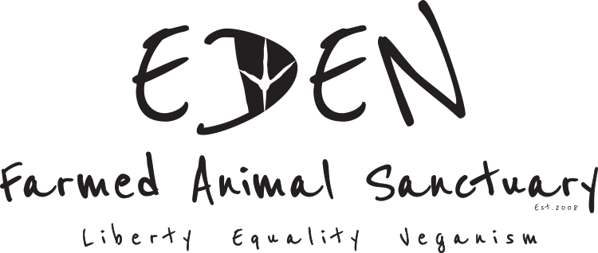Animal Caregiver Application Form March 2020

Applicant Information
Last Name |  |  |  |  |  |  |  |  | First |  |  |  |  |  |  |  |  | DOB |  |  |  |  |  |  |  | Gender M/F/Other
Address
Town |  |  |  |  |  |  |  |  |  |  |  | County |  |  |  |  |  |  |  |  |  |  | Postcode
Phone |  |  |  |  |  |  |  |  |  |  |  |  | E-mail Address
Driver’s License |  |  |  |  |  |  |  |  |  | Are you licensed to drive farm machinery? |  |  |  |  |  |  |  |  |  |  | Do you have your own transport?
Are you authorized to work in Ireland? |  |  |  |  |  |  |  |  |  |  |  |  |  | Are you willing to relocate and live close to Eden?
English Language Fluency? |  |  |  |  |  |  |  |  |  |  |  |  |  |  |  | Up to date Tetanus shot?

Education

School/  College |  |  |  |  |  |  |  |  |  |  |  | Address
From |  |  |  |  |  |  |  |  |  |  |  | To
Did you graduate? |  |  |  |  |  |  |  |  |  |  |  | YES |  |  |  |  | NO |  |  | Degree
Subjects Studied
Qualification Obtained
School/  College |  |  |  |  |  |  |  |  |  |  |  | Address
From |  |  |  | To |  |  |  | Did you graduate? |  |  |  | YES |  |  |  |  |  | NO |  | Degree
Other |  |  |  |  |  |  |  |  |  |  |  | Address
From |  |  |  | To |  |  |  | Did you graduate? |  |  |  | YES |  |  |  |  |  | NO |  | Degree

References
Please list two references from previous employers References must include email address.
Full Name |  | Relationship
Company |  | Phone
Address
Email address
Full Name |  | Relationship
Company |  | Phone
Address
Email address

Previous Employment
Company |  |  |  |  |  |  |  |  |  | Phone
Address |  |  |  |  |  |  |  |  |  | Supervisor
Job Title
Responsibilities
From |  |  |  |  |  | To |  | Reason for Leaving
May we contact your previous employer for a reference? |  |  |  |  |  |  |  |  | YES | NO
Company |  |  |  |  |  |  |  |  |  | Phone
Address |  |  |  |  |  |  |  |  |  | Supervisor
Job Title
Responsibilities
From |  |  |  |  |  | To |  | Reason for Leaving
May we contact your previous employer for a reference? |  |  |  |  |  |  |  |  | YES | NO
Company |  |  |  |  |  |  |  |  |  | Phone
Address |  |  |  |  |  |  |  |  |  | Supervisor
Job Title
Responsibilities
From |  |  |  |  |  | To |  | Reason for Leaving
May we contact your previous employer for a reference? |  |  |  |  |  |  |  |  | YES | NO
Signature |  |  |  |  |  |  |  |  |  |  |  |  |  | Date

Previous Experience of animal care/sanctuary work/any other relevant volunteer or employment experience in an animal CARE context
Company |  |  |  |  |  |  |  |  |  | Phone
Address |  |  |  |  |  |  |  |  |  | Supervisor
Job Title
Responsibilities
From |  |  |  |  |  | To |  | Reason for Leaving
May we contact your previous employer for a reference? |  |  |  |  |  |  |  |  | YES | NO
Company |  |  |  |  |  |  |  |  |  | Phone
Address |  |  |  |  |  |  |  |  |  | Supervisor
Job Title
Responsibilities
From |  |  |  |  |  | To |  | Reason for Leaving
May we contact your previous employer for a reference? |  |  |  |  |  |  |  |  | YES | NO
From |  |  |  |  |  | To |  | Reason for Leaving
May we contact your previous employer for a reference? |  |  |  |  |  |  |  |  | YES | NO
Company |  |  |  |  |  |  |  |  |  | Phone
Address |  |  |  |  |  |  |  |  |  | Supervisor
Job Title
Responsibilities
From |  |  |  |  |  | To |  | Reason for Leaving
May we contact your previous employer for a reference? |  |  |  |  |  |  |  |  | YES | NO

Desirable (but not essential) Animal Care Skills

What species of animals have you previously worked with?

Please list your specific animal care skills
Please tick the animal care tasks that you are skilled and experienced in:
Hoof trimming (name species)
Handling large animals (name species)
Vaccinations and other medicines
Sub-cutaneous injection
Intra-muscular injection
Oral
Movement and transport of animals (name species)
Please describe any experience you have of caring for birds.
Please list any other skills you have such as knowledge of animal feeding, licence to drive tractor, ability to move bales of hay and straw, making hay, shearing sheep etc.
Do you have any skills in farm maintenance work such as basic carpentry, repairing fencing etc.
Are you vegan?
Please list your reasons for being vegan.

If you are not vegan please note that we are a vegan sanctuary and out of respect to the residents whose sanctuary Eden is, animal products are not permitted onsite. Please let us know if you anticipate a difficult with this aspect of the employment situation.

Are you involved in any other animal rights organization? Please list and detail your involvement.

Other Information

Hobbies & Interests

Please list any other relevant skills
Are you involved in any other animal rights organization? Please list and detail your involvement.

Disclaimer and Signature
I certify that my answers are true and complete to the best of my knowledge.
If this application leads to employment, I understand that false or misleading information in my application or interview
may result in termination of my employment.

Signed: ___________________________________________________________ Date: ___________________________________

Please feel free to use extra paper and to add a CV to your application form.

Please return completed form by email to info@edenfarmedanimalsanctuary.com

Please note that incomplete application forms are excluded from consideration. References must be from former employers rather than from work colleagues, family or friends.

